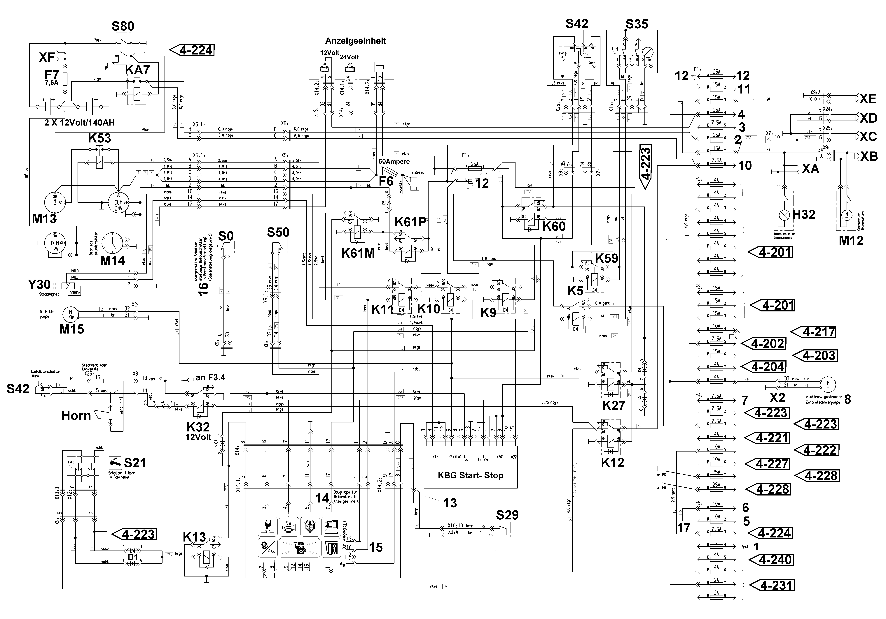

Operating Voltage
4-200 A
from DCF 880001
to DCF 880060
01/2001 TC Neustadt

