[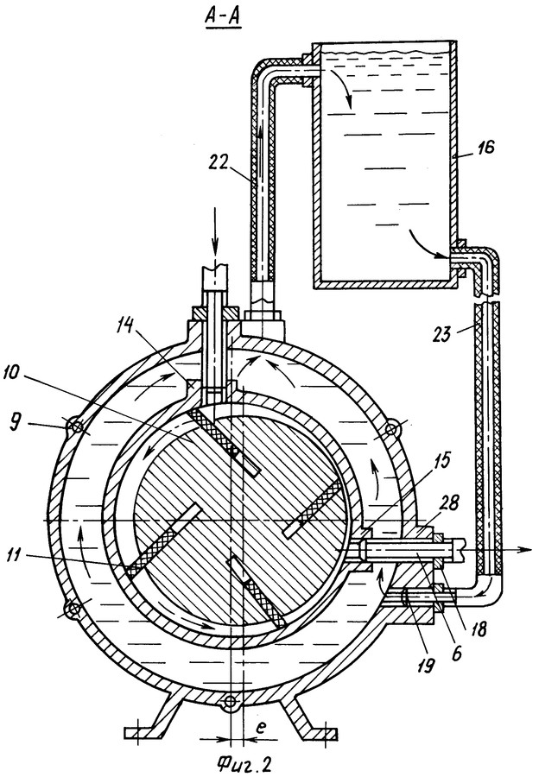](http://www.google.ru/url?sa=i&rct=j&q=&esrc=s&frm=1&source=images&cd=&cad=rja&uact=8&ved=0CAcQjRxqFQoTCIzNzKOEhMYCFcsXLAod7_8Icg&url=http%3A%2F%2Fwww.freepatent.ru%2Fpatents%2F2265321&ei=tZp3VcyeO8uvsAHv_6OQBw&bvm=bv.95039771,d.bGg&psig=AFQjCNEhBuUE1wj2vn-PRur-_n8rkbKlww&ust=1433987945931278)[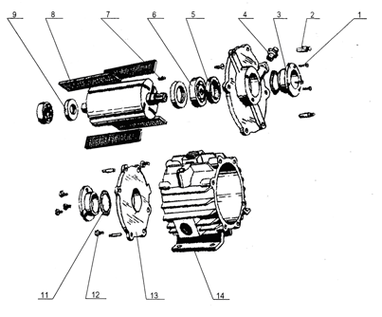](http://www.google.ru/url?sa=i&rct=j&q=&esrc=s&frm=1&source=images&cd=&cad=rja&uact=8&ved=0CAcQjRxqFQoTCIzNzKOEhMYCFcsXLAod7_8Icg&url=http%3A%2F%2Fwww.ksm45.narod.ru%2Fcatalog%2Fdust%2Fuvd10000.html&ei=tZp3VcyeO8uvsAHv_6OQBw&bvm=bv.95039771,d.bGg&psig=AFQjCNEhBuUE1wj2vn-PRur-_n8rkbKlww&ust=1433987945931278)