Makita DCS7300
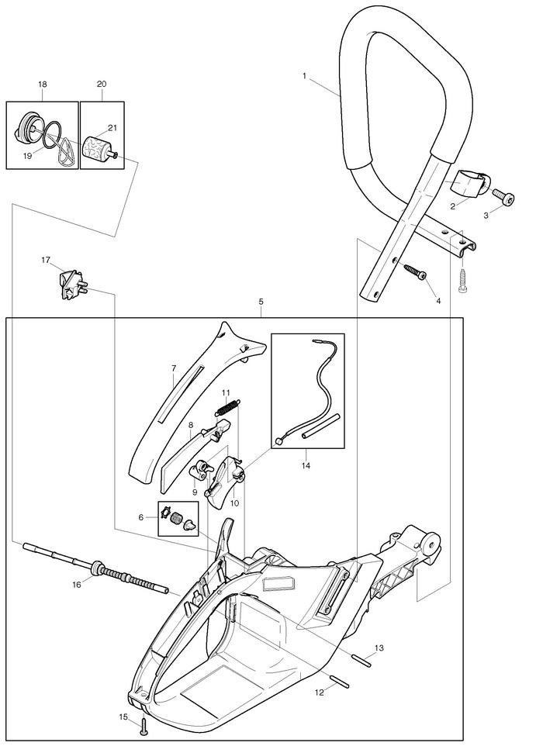
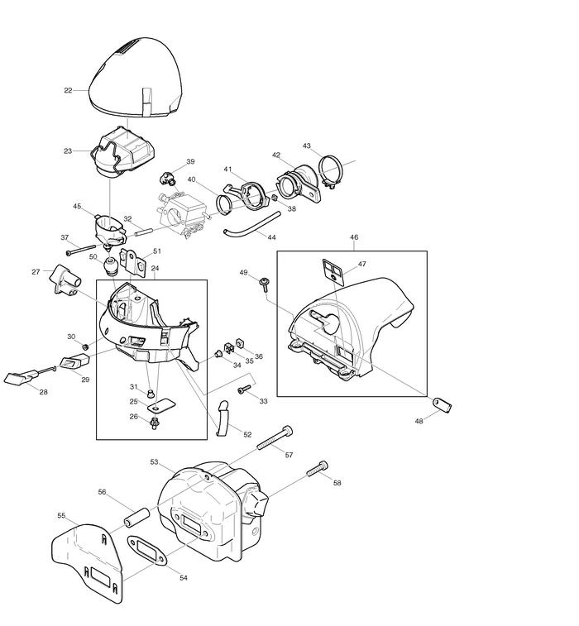
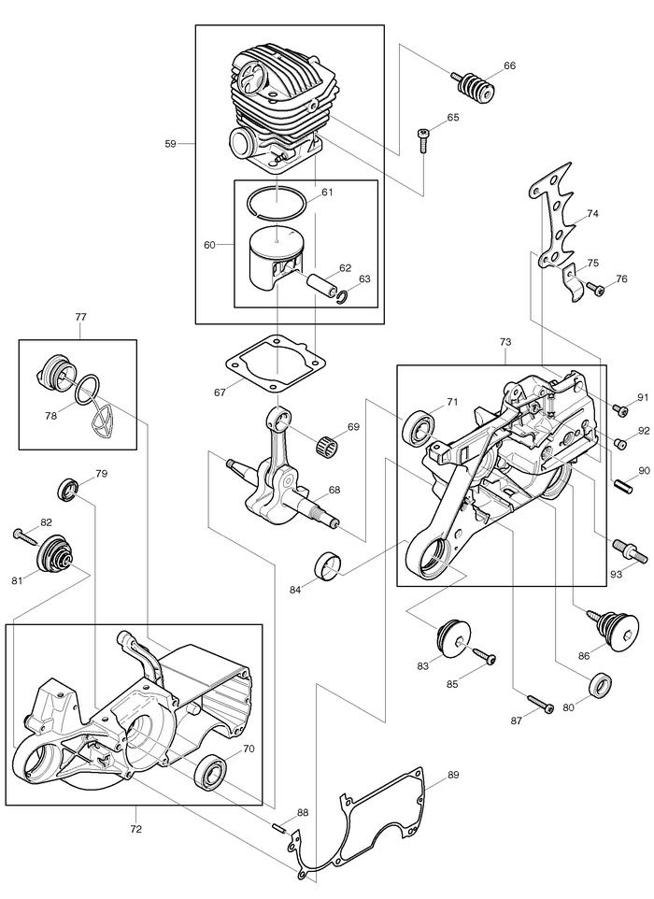
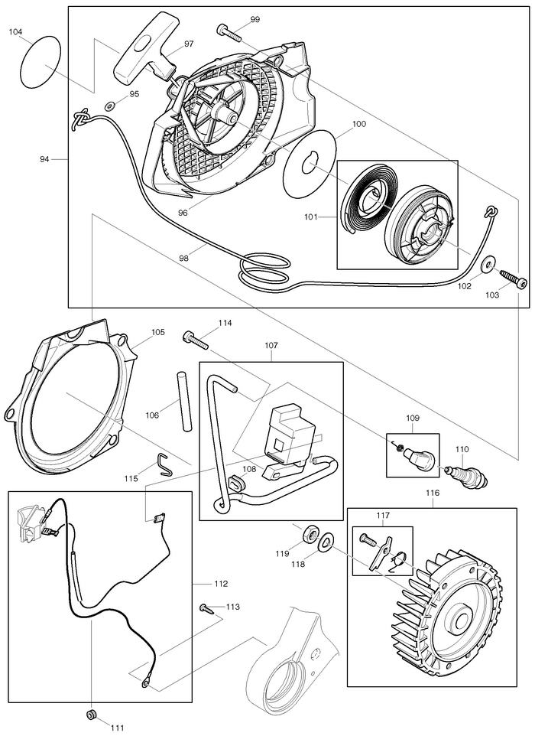
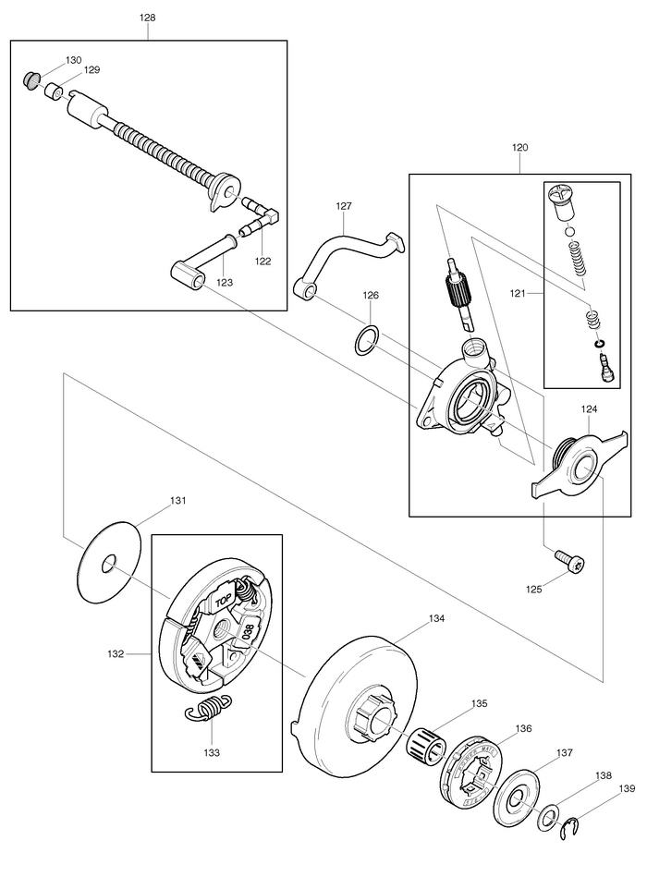
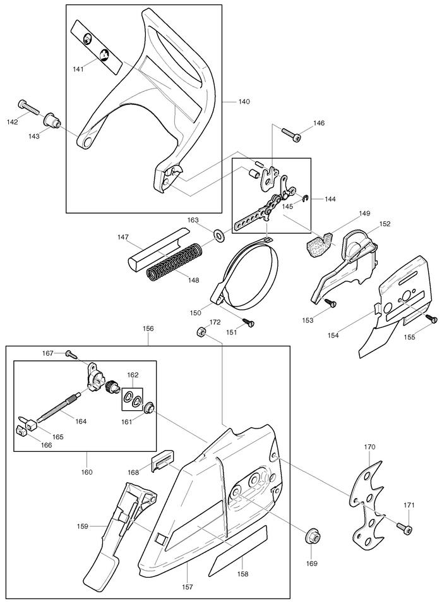
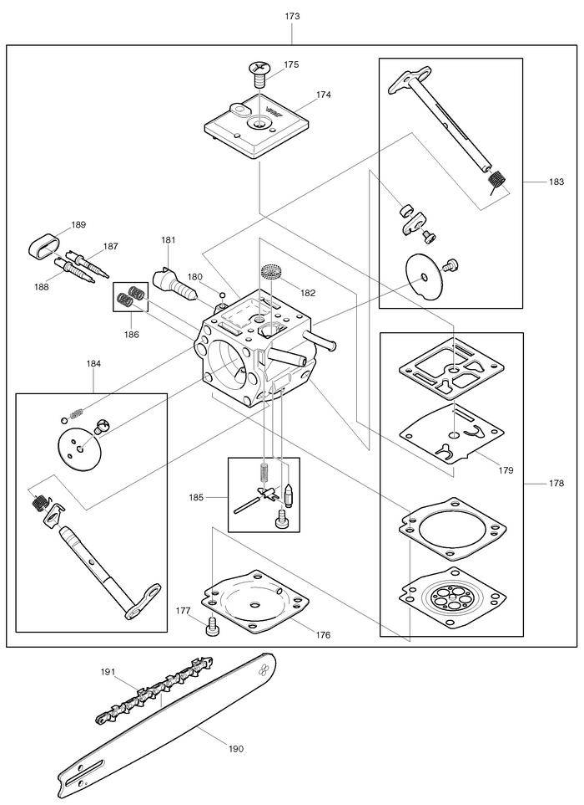

1 | 038310020
2 | 038310060
3 | 908006145
4 | 913455204
5 | 038114600
5 |  | INC. 6-16
6 | 957114060
7 | 038114630
8 | 038117020
9 | 038117030
10 | 038117010
11 | 038117050
12 | 935930240
13 | 935930280
14 | 010117040
15 | 913340204
16 | 038114050
17 | 975001210
18 | 010114050
18 |  | INC. 19
19 | 963228030
20 | 963601130
20 |  | INC. 21
21 | 963601240
22 | 038118620
23 | 038173100
23 | 038173010
24 | 038118630
24 |  | INC. 25,26,31
25 | 038118110
26 | 938650062
27 | 038118080
28 | 038155050
29 | 038155020
30 | 965401020
31 | 001118100
32 | 038155050
33 | 908005205
34 | 001118100
35 | 038111050
36 | 038111060
37 | 908204555
38 | 921804004
39 | 038155010
40 | 038131030
41 | 038171041
42 | 038131010
43 | 965603050
44 | 965452380
45 | 038171010
46 | 038118610
47 | 038118140
48 | 038118130
49 | 917105205
50 | 038171030
51 | 038118100
52 | 038118071
53 | 038174200
54 | 965531130
55 | 038174020
56 | 038174030
57 | 908305405
58 | 908405205
59 | 039130020
59 |  | INC. 60
60 | 394132111
60 |  | INC. 61-63
61 | 394132020
62 | 119132030
63 | 119132060
65 | 908005205
66 | 038114150
67 | 965531121
68 | 038120020
69 | 962210019
70 | 960102159
71 | 960102179
72 | 038111630
72 |  | INC. 70
73 | 038111640
73 |  | INC. 71
74 | 038250020
75 | 038111080
76 | 908005165
77 | 010114050
77 |  | INC. 78
78 | 963228030
79 | 962900052
80 | 962900061
81 | 038114130
82 | 913455204
83 | 038114130
84 | 038114190
85 | 913455204
86 | 038114140
87 | 908005305
88 | 936430160
89 | 038111042
90 | 934660250
91 | 908005125
92 | 010245030
93 | 038232010
94 | 038160600
94 |  | INC. 95-103
95 | 928405000
96 | 038112630
97 | 001161010
98 | 108164020
98 | 985000155
99 | 908605205
100 | 038162050
101 | 038162021
102 | 924605510
103 | 913455204
104 | 980114789
105 | 038112020
106 | 970502110
107 | 038143020
107 |  | INC. 108
108 | 038143030
109 | 957604240
110 | 965603021
111 | 965401011
112 | 970311540
113 | 915135100
114 | 908304205
115 | 038111110
116 | 038141000
116 |  | INC. 117
117 | 108166051
118 | 926208001
119 | 920208024
120 | 038245010
120 |  | INC. 121,124
121 | 030245070
122 | 001245140
123 | 038245110
124 | 038245030
125 | 908005125
126 | 038224020
127 | 038245060
128 | 038245020
128 |  | INC. 122,123,129,130
129 | 900005066
130 | 963601100
131 | 001182041
132 | 038180010
133 | 024184021
133 |  | INC. 140
134 | 038223020
135 | 962210024
136 | 119224070
137 | 001224011
138 | 021224010
139 | 927408000
140 | 038213220
140 |  | INC. 141
141 | 980114237
142 | 908405205
143 | 038213160
144 | 957213030
144 |  | INC. 145
145 | 927304000
146 | 908005206
147 | 038213150
148 | 038213130
149 | 038213200
150 | 038213010
151 | 915135100
152 | 038213040
153 | 915135100
154 | 038111030
155 | 915135100
156 | 038213600
156 |  | INC. 157-160,167,168
157 | 038213635
158 | 980114784
159 | 038213190
160 | 957213020
160 |  | INC. 162,164-166
161 | 038213080
162 | 038213210
163 | 028213010
164 | 038213120
165 | 038213090
166 | 038213070
167 | 915135100
168 | 024213240
169 | 923208004
170 | 957250060
171 | 908005125
172 | 920405000
173 | 038153010
173 |  | INC. 174-178,180-189
174 | 038153030
175 | 038153360
176 | 038153040
177 | 001153020
178 | 038153060
178 |  | INC. 179
179 | 038153070
180 | 038153210
181 | 038153220
182 | 028153180
183 | 957153060
184 | 957153050
185 | 957153070
186 | 038153260
187 | 038153230
188 | 038153240
189 | 038153270
190 | 445038655
190 | 445045655
190 | 445050655
190 | 445060655
191 | 528099660
191 | 528099668
191 | 528099672
191 | 528099683
1001 | 952100643
1001 | 952100653
1002 | 940827000
1003 | 941719131
1004 | 944340001
1005 | 950004001

