; 02 54 23 1 1 24

14-06-07:01:20PM;

220

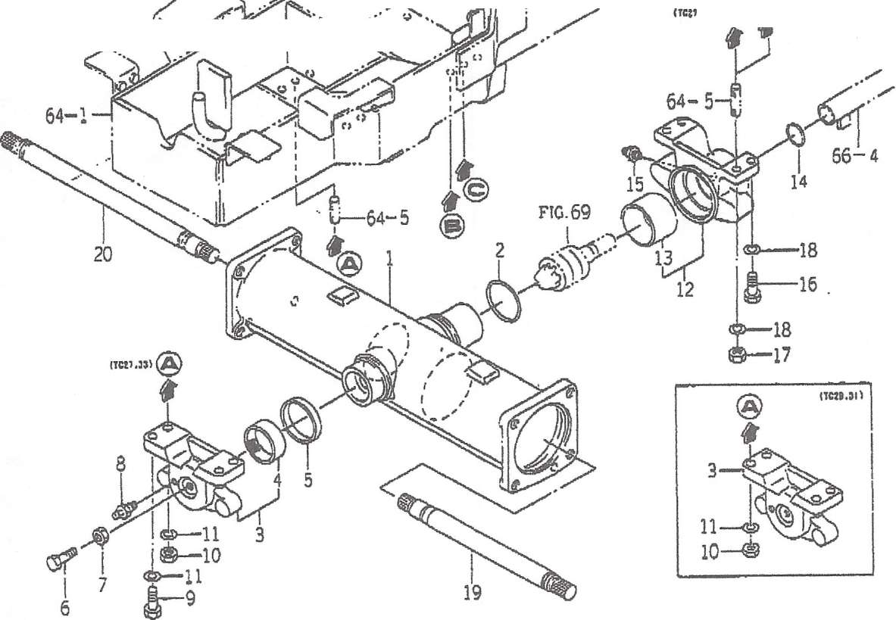

FIG. 70 (7/7 *;[,)

ш 06S10

W

|  |  |  |  |  |  |  |  |  |  |  |  |
| --- | --- | --- | --- | --- | --- | --- | --- | --- | --- | --- | --- |
| !1# | SIS во з - к | нЬ 35 | ш £ | m st | | | | ft a is | a I*- | | « % |
| TG27 | TG29 | TG31 | TG33 | sc | r |
| 1 | 1651 -433 -001 - 10 | IWMVW | 1 |  | ♦ | t | • | 3 |  |  |  |
| 2 | V?2l - 103- 107-50 | 0 TJf | 1 | * |  | * | a |  |  |  |  |
| 3 | 1650-433-200- 10 | W(»'7l-/7Dn)ASSY | 1 | t | * | * | k | 1 |  |  |  |
|  | 16so - 433 - гог - oo | Vjl (62X57X20) | 1 | a | « | » | ♦ |  |  |  |  |
| 5 | 1614-433-002-00 |  | 1 | * | t | # | 4 |  |  |  |  |
| 6 | V201 -261 -203-50 | mm | 1 | « | * | ■i | e |  |  |  |  |
| 7 | V304 - 260 - 012 - 00 | mm | 1 | * | • | t | ♦ |  |  |  |  |
| 8 | V7S1 - 150-000-00 | ini'm | 1 | • | ♦ | » | It |  |  |  |  |
| 9 | V201 -361 -203-50 | mm | г | » | » | * | » |  |  |  |  |
| 10 | V304 - 460 - 012 - 00 | mm | 2 | * | > | ♦ |  |  |  |  |  |
| n  "12" | V401 - 160 - 012 - 00 | s.w |  |  | * | 9 | t |  |  |  |  |
| 1650-433-210-10 | m(wwm assy |  | * | * | i | * | 1 |  |  |  |
| !3 14 | 1564 - 433 - 222 - 10 | Vjl (65X70X44) | i | * | t | ♦ | * |  |  |  |  |
| V720- 103-503-40 | O'M | i | » | * | « | 1 |  |  |  |  |
| 15 | V7B1 - 150-000-00 | mz°m | i | t | * | • | » |  |  |  |  |
| 16 | V201 -361 -203-50 | mm | 2 | t | * | « | * |  |  |  |  |
| 17 | V304 - 460 - 012 - 00 | mm | 2 | 4 | » | * | » |  |  |  |  |
| 18 | V401 - 160-012-00 | s.w | 4 | » | * | « | * |  |  |  |  |
| 19 | 1551 -433-002-00 |  | 1 | f | ♦ | • | » |  |  |  |  |
| го | 1651 -433-003-00 |  | 1 |  | 9 | t | • |  |  |  |  |
|  |  |  |  |  |  |  |  |  |  |  |  |
|  |  |  |  |  |  |  |  |  |  |  |  |
|  |  |  |  |  |  |  |  |  |  |  |  |
|  |  |  |  |  |  |  |  |  |  |  |  |
|  |  |  |  |  |  |  |  |  |  |  |  |

FIG. 72 (Ф>-/7а>Ь) Ш (16Я№<)

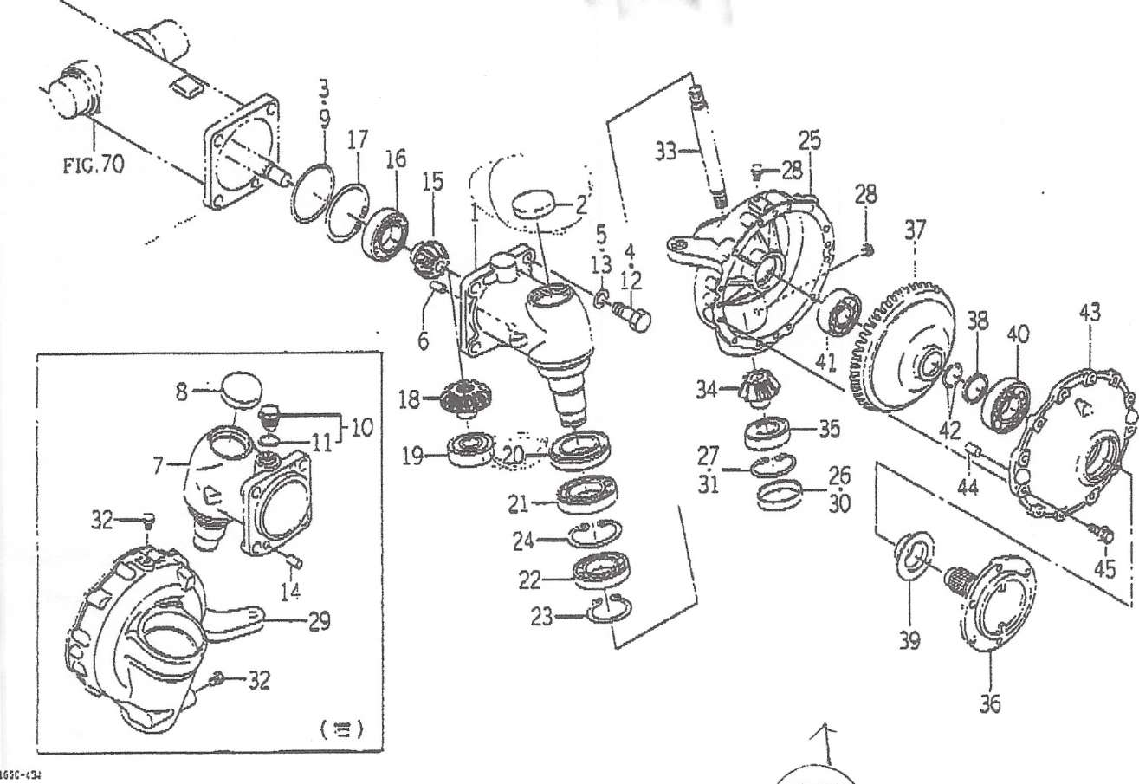

|  |  |  |  |  |  |  |  |  |  |  |  |
| --- | --- | --- | --- | --- | --- | --- | --- | --- | --- | --- | --- |
|  | Sfl & 3 - К | 00 Й | » |  |  | X |  | to | si |  | l/ffl # |
|  | s | TG27 | TG29 | TG31 \ |  | I | 1  У |
| ! | 1650-434-001 -10 |  | i | 8 | * | a | г | 3 |  |  |  |
| t/2 | 1650-434-003-00 | "Q | i | 0 |  | a | » |  |  |  |  |
| '3 | V721 -103-111 -00 | Q'JVJ" | i | й | » | a | a |  |  |  |  |
| 4 | V201 -361 -404 - 00 | mm | 4 | » | < | a | # |  |  |  |  |
| 5 | V401 - 160-014-00 | s. w | 4 | * | « | a | a |  |  |  |  |
| 6 | V520- 101 -002-20 | vf3«V<A) | 1 | id | t | a | ♦ |  |  |  |  |
| 7 | 1650-434-002-Ю | *-*(77W/RH) | 1 | a | t | a | ♦ | 3 |  |  |  |
| 8 | 1650-434-003-00 |  | 1 | * | « | a | * |  |  |  |  |
| 9 | V721 -103-111-00 |  | 1 | * | a | a | » |  |  |  |  |
| 10 | 1518-432-250-00 | ASSY | 1 | £ | a | ♦ | a |  |  |  |  |
| 11 | 1518 - 305 - 203 - 00 | /mv | 1 | S | a | * | ♦ |  |  |  |  |
| 12 | V201 -361 -404 - 00 | wm | 4 | 0 | a | a | a |  |  |  |  |
| 13 | V401 - 160 - 014 - 00 | s.w |  | • | a | a | a |  |  |  |  |
| 14 | V520- 101 -002-20 | MJ9k'V(A) |  |  | ♦ | a | t |  |  |  |  |
| 15 | 1650-434 -004-00 | (-WV/11) | 2 | f | * | a | a |  |  |  |  |
| 16 | V600- 110-620-80 | R. В. В | 2 | * | • | * | a |  |  |  |  |
| 17 | V707- 140 - 080 - 00 | ттнтг) | 2 | * | a | a | a |  |  |  |  |
| 18 | 1650 - 434 - 005 - 00 | It- (t^/17) | 2 | t | a | a | a |  |  |  |  |
| 19 | 1560-206-003-00 | 'ОТЯОИИ | 2 | t | » | a | a |  |  |  |  |
| 20 | 1650-434-006-00 | CI | 2 | 9 | a | a | a |  |  |  |  |
| 21 | V600- 110-601 -20 | R. В. В | 2 | 4 | » |  | t |  |  |  |  |
| 22 | V600- 110-601 -00 | R. В. В | 2 | 9 | * | » | a |  |  |  |  |
| 23 | V706 - 140 - 050 - 00 | zrmvnm | 2 | « | a | a | * |  |  |  |  |
| 24 | V707- 140 - 080 - 00 | WJVMtft) | 2 | t | * | i | ♦ |  |  |  |  |
| 25 | 1650-434-007-00 | t-iwm/ LH) | 1 | * | % | 5 | * |  |  |  |  |

It 3/ 3

; 02 54 23 1 1 24

1 4-06-07 : 0 1 : 2 0PM;JAM МСМ№9-