[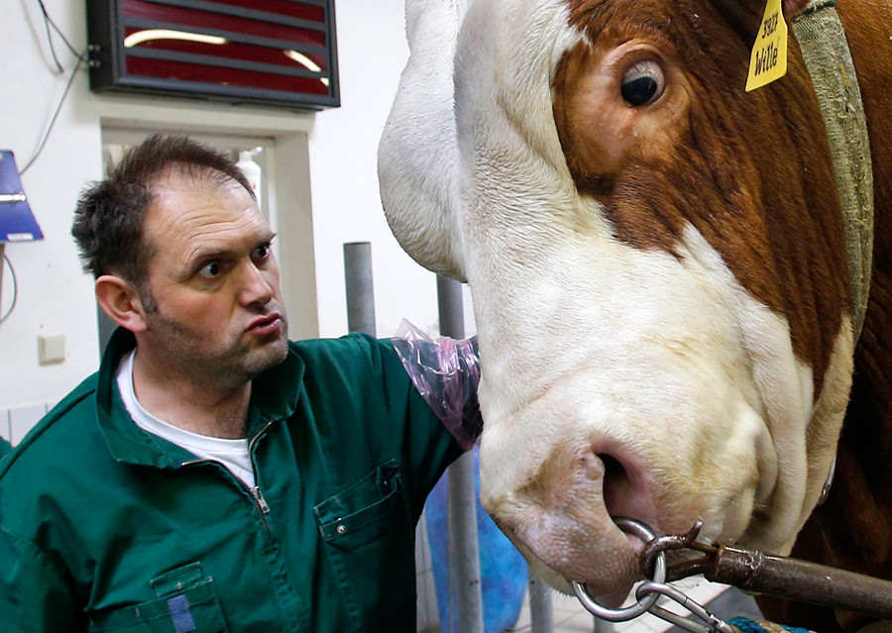](http://image1.org/image.php?id=156618&p=26ihoach)

[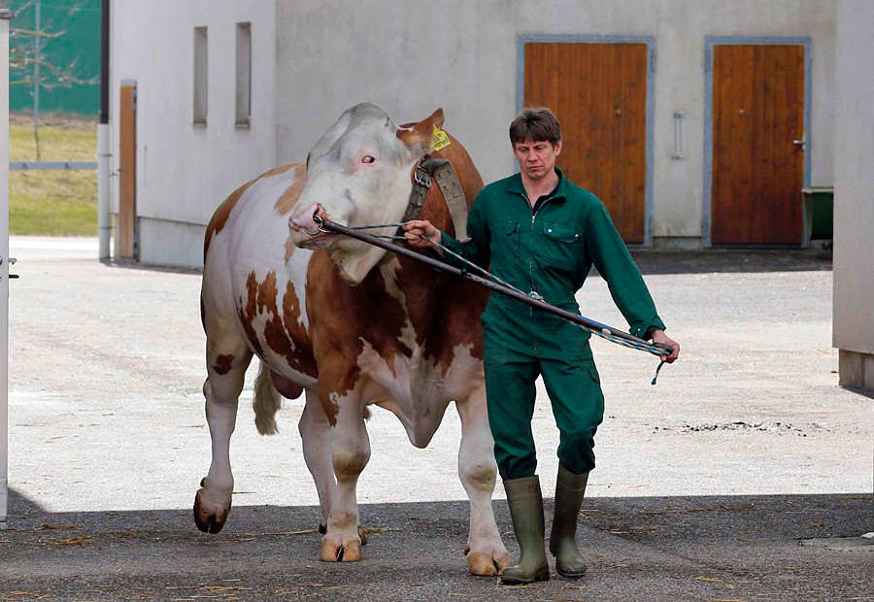](http://image1.org/image.php?id=156616&p=v1ov894n)