RESYNCH -7
ReSynch -7 is an even more aggressive resynchronization strategy in which the first GnRH injection for the second synchronization (resynchronization) is given 7 days before the pregnancy diagnosis (day 0). Although cows receive a GnRH at unknown pregnancy status, GnRH does not have negative impact on pregnant cows. By using resycnh -7 open cows receive PGF2α immediately after pregnancy diagnosis, and are inseminated 2 (CoSynch) or 3 (OvSynch) days after pregnancy check. With this program you will resubmit all open cows for a second A.I. one week earlier compared to ReSynch 0.

PROCEDURE:
DAY 0: Timed AI
DAY 26: Inject GnRH to all cows (unknown pregnancy status).
DAY 33: Pregnancy check. INJECT PGF2α ONLY TO OPEN COWS.
DAY 35: Inject GnRH and Timed AI according to the program selected.

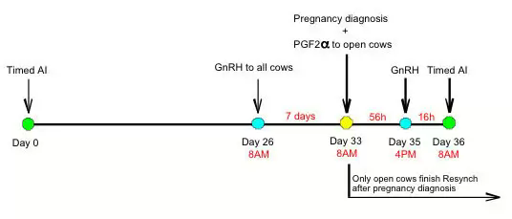

FEATURES:

* Do not conduct ultrasound before day 33 post breeding, since you would be giving GnRH earlier that Day 26. Administration of GnRH before Day 26 post TAI may reduce you possibilities of success.
* Rapid ReSynch, a modification of ReSynch, gives PGF2α to open cows at the time of pregnancy diagnosis, but does not administer the first GnRH. This program might yield inconsistent results because no follicular wave is synchronized, thus stage of follicular development at Timed AI is unknown.

