Prostaglandin (телки)
An injection of prostaglandin F2a (PGF2α) is given at a random stage of the cycle.
Animals with an active corpus luteum (CL) will undergo CL regression after the PGF2α challenge and will come into heat between 2-7 days after the shot.
Animals detected in estrus can be bred.
Only those animals not showing heat (and not bred) after the first shot, will receive a second PGF2α injection 11-14 days after the first PGF2α and should be bred accordingly.
It is not recommended to conduct TAI after a PGF2α synchronization program, since the follicular wave was not synchronized and the stage of follicular maturation is uncertain.

Important: prostaglandin cannot be used in pregnant animals – it will likely induce abortion.

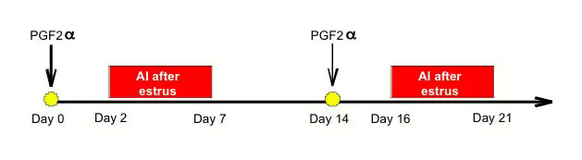

FEATURES:

* Effective and inexpensive program to breed dairy and beef heifers and beef cows.
* Prostaglandin causes regression of the CL. Bred animals should be dropped from the rest of the treatment.
* Young heifers (i.e. 11-12 months of age) and early postpartum cows (less that 30 DIM) should not be bred after the first shot.
* By rectal palpation or ultrasound examination, you can also determine the presence of a Corpus Luteum (CL), and only these animals will receive the first shot. The second shot will be given to animals not bred and/or not receiving the first shot.

