PRESYNCH with two PGF + Ovsynch (only for first postpartum AI)

PreSynch is a modification of OvSynch in which two PGF2α injections 14 days apart are administered, with the second PGF injection 12 days before initiation of the first GnRH injection of OvSynch. PreSynch improves first service conception rate compared to OvSynch and is a good strategy for programming cows to receive their first postpartum timed A.I. Some people prefer to keep using 14 days between the second PGF and the initiation of Ovsynch, but the need to be aware of a small decrease in fertility compared to the 12 day interval.

PROCEDURE:
DAY 0: PGF to start pre-synchronization (ie: 6-8 am)
DAY 14: Second PGF should be used at the end of the voluntary waiting period, normally, around 50 days in milk (ie: 6-8 am)
DAY 26: Inject GnRH to ovulate follicle and start a new follicular wave (ie: 6-8 am)
DAY 33: Inject PGF2α to regress CL (ie: 6-8 am)
DAY 35: Inject GnRH to ovulate follicle (ie: 2-4 pm)
DAY 36: Timed AI 12-16 hours after second GnRH - (ie: 6-8 am)

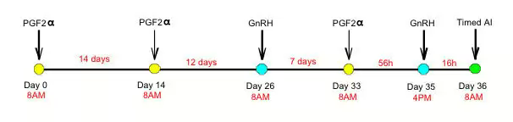

FEATURES:

* This system requires a long duration and timing. It is good for dairy cows that will receive their first postpartum timed A.I. The figure above shows a time line of DIM, thus a cow receiving TAI at 68 DIM, should receive her first PGF2α. Injection at 30 DIM.
* Not a good resynchronization tool because of the long duration.
* Studies have shown that conception rate was greater for cows receiving PreSynch vs. OvSynch.

