OVSYNCH-56

OvSynch-56 is a new modification of the original protocol that gives the second GnRH injection 56 hours after PGF2α and TAI 16 hours later (72 hours after the PGF2α. OvSynch-56 improved conception rates in almost 10 percent compared to OVSynch.

PROCEDURE:
DAY 0: Inject GnRH to ovulate follicle and start a new follicular wave (ie: 6-8 am)
DAY 7: Inject PGF2α to regress CL (ie: 6-8 am)
DAY 9: Inject GnRH to ovulate follicle (ie: 2-4 pm)
DAY 10: Timed AI 12-16 hours after second GnRH - (ie: 6-8 am)

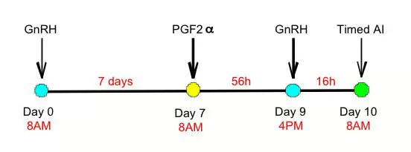

FEATURES:

* Should be used in conjunction with PreSynch.
* OvSynch-56 improved conception rates in almost 10 percent points compared to OvSynch.
* Cows detected in estrus should be bred accordingly.
* Allows more time for follicular maturation compared to OvSynch.

