OVSYNCH -48h
OvSynch uses PGF2α and GnRH to synchronize ovulation in lactating dairy cows. OvSynch was the first synchronization protocol developed that allowed for timed AI (TAI) resulting in conception rates similar to that of A.I. after a detected estrus.

PROCEDURE:
DAY 0: Inject GnRH to ovulate follicle and start a new follicular wave (ie: 3-5 pm)
DAY 7: Inject PGF2α to regress CL (ie: 3-5 pm)
DAY 9: Inject GnRH to ovulate follicle (ie: 3-5 pm)
DAY 10: Timed AI 12-16 hours after second GnRH - (ie: 7-9 am)

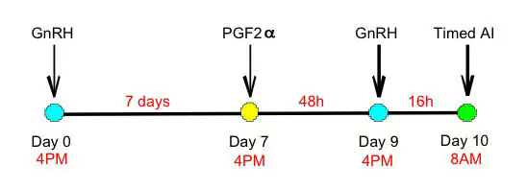

FEATURES:

* GnRH causes ovulation and initiation of a new follicular wave.
* Prostaglandin causes regression of the corpora lutea.
* The second GnRH synchronizes the time of ovulation of the dominant follicle of the follicular wave that began growing after the first GnRH injection.
* Cows don't necessarily need to respond to the first GnRH injection to synchronize to the second GnRH injection.

Return to the Top

